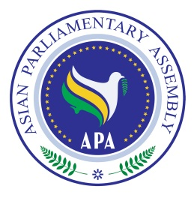
Asian Parliamentary Assembly
APA Coordinating Meeting Alongside
the 148th IPU Assembly
Saturday 23 March 2024 (Hour: 15:00 -16:30)
Venue: Plenaries E& F, on the 3rd Floor of the GICG
Geneva- Switzerland
Registration Form

Please fill in one registration form for each participant in (block letters) and return it to the APA Secretariat at the following e-mail address latest by 15 March)
- Delegation of: …………

- Title: Please check Mr. Ms. Dr. other
- First Name:
- Last Name:

- Position in the parliament
……………………………………………………………………………………

- Phone No. | - …………………..……………………………………………..  - Country Code City Code Number
- Cell phone  - Fax No. | - …………………………………………………………………  - ………………………………………………………………..
- Email Address: | - ……………….……………………………………………..

Any Proposal on Emergency Item:

